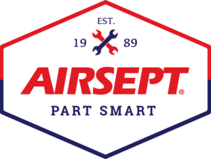

News Release

AIRSEPT INTRODUCES SMART SPLICE™ REPAIR KITS
FOR THE COLLISION REPAIR MARKET
Line Connectors that quickly and efficiently repair transmission, power steering
and A/C lines on-site for quicker collision repair turnaround
Atlanta – August 2, 2022 – No one wants to have their car in the shop for longer than it needs to be there. AirSept’s fluid line connectors are an easy and economical way to improve repair turnaround.
AirSept is recognized for developing innovative award-winning solutions for complex automotive repair problems, including line repair solutions that can save collision shops both time and money. AirSept’s Smart Splice line repair connectors have been used by auto care professionals for many years to make quick, durable repairs to A/C, transmission and power steering lines without adhesives or special tools. Now, Smart Splice products are available for the collision market to ensure that vehicles are repaired efficiently onsite at the shop so the real work of repairing the body damage can be done.
Chuck Abbott, AirSept VP of Sales says, “There are multiple instances where damaged lines fit into the autobody repair workflow. For example, there are instances where the lines are damaged to the point of leakage caused by a collision or when components must be removed to complete a body repair. In both instances, AirSept line repair will make these jobs easier, faster, and equal in quality to line replacement.”
The AirSept Smart Splice Ultimate System offers five trays of line repair solutions for air conditioning, power steering, and transmission lines. The AirSept PROSeries Smart Splice system is offered in two convenient kits – transmission and power steering and air conditioning repair.
AirSept’s PROSeries Trans and P/S kit offers 16 unique repair options. The kit includes Smart Splice connectors for straight, 45˚, and 90˚ line-to-line repairs along with Smart Splice connectors for line-to-hose repair covering almost all transmission and power steering return lines.
The Smart Splice PROSeries A/C kit includes 18 repair solutions to keep vehicles cool and comfortable year-round. Smart Splice connectors in this kit include everything needed for straight or 90˚ line-to-line, straight line-to-hose, and hose-to-hose repairs.
Smart Splice™ line repair connectors feature a proprietary sealing technology that makes them superior to compression fittings to ensure a long-lasting service life. Smart Splice connectors save time, money and the hassle of sending vehicles out for line replacement or repairs.
For more information on AirSept’s OE approved line connectors, including the Smart Splice PROSeries and Ultimate System kit, visit AirSept.com, email sales@airsept.com, or call 678.973.2287.
# # # #
Image Attached: 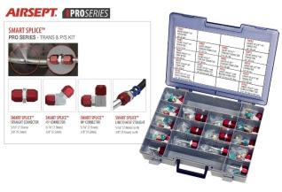
Caption: AirSept PROSeries Trans and Power Steering Kit

About AirSept
In 1989 AirSept created the first long-lasting solution to the problem of unwanted mold and mildew odor in automobile air conditioning systems. The product quickly became popular and in 1991 AirSept was incorporated as a company. AirSept began partnering with global OEMs and suppliers to not only market its Cooling Coil Coating, but to also develop other unique, new problem-solving products. From those humble beginnings, AirSept has grown to be the industry leader in the development of OEM and aftermarket solutions to complex automotive repair problems. AirSept products are designed to save time, money and labor. For more information, visit www.AirSept.com.
For further product information, contact:
Chuck Abbott / Vice President Sales & Marketing / AirSept
678-973-2287
cabbott@airsept.com

Leslie Allen / Owner / Wildcat Communications
615-429-7965
leslieallen.wildcat@gmail.com

